**Software Requirements Specifications**

**Rental Application**

**Author(s): Raghul S M**

**Version:** 2.0

**Date:** 22-11-2024

Contents

**1. Abstract..………………………………………………………………………..……………………….……4**

**2. Module description…………………………………………………………………………………….…..4**

2.1 Log in/ Sign in……………………………………………………………………………………………………………….……4

2.2 Home Page………………….……………………………………………………………………………………………………..4

2.3 Product Page…….………………………………………………………………………………………………………………..4

2.4 Wish List……….…………………………………………………………………………………………………………………….5

2.5 Add to List………….……………………………………………………………………………………………………………….5

2.6 Payment page……….…………………………………………………………………………………………………………….5

**3. Functional requirements…………………………………………………………………………5**

3.1 Login requirements…………………………………………………………………………………………………………….5

3.2Page requirements……………………………………………………………………………………………………………..5

3.3 Product list requirements…………………………………………………………………………………………………..5

3.4 Purchase requirements……………………………………………………….………………………………………………6

**4. Non Functional requirements……………………………………………….………………………….6**

4.1 Display requirements………………………………………………………………………………………………………….6

4.2 Graphical requirements……………………………………………………………………………………………6

**5. High level design……………………………………………………………………………………………6**

**6. Diagrams………………………………………………………………………………………………………7**

6.1 Use case diagram……………………………………………………………………………………………………………….7

6.2 Class diagram……………………………………………………………………………………………………………………..8

6.3 Flow chart……………………………..…………………………………………………………………………………9

6.4 Entity relationship diagram………………………………………….............................................10

6.5 Sequence diagram…………………………………………………………………………………………………….......11

**7. Test case………………………………………………………………………………………..……………12**

**1. Abstract**

The main purpose of this web application is to provide the user a rental service where user can rent various products and services in a single click. Rent It is an online rental application where user can rent automobile and gadgets. When the user wants to rent an item they have to create and account by clicking Sign up, If already have an account then have to log in. After Log in, User will take to homepage. Users can also wish list the items they want by clicking “Add to Wish List” and they can rent more than one item by clicking on “Add to List”. Once confirm the amount user have to pay.

**2. Module description**

1. **Log in/Sign up**

The application starts with the Log in/Sign up page. Here the user has to give their login details, if they are new to the page they have to Sign up by give their username, email and password. Once they are Log in/Sign up they are taken to the home page.

1. **Home page**

Homepage consist of product segments that are available for rent. When user click on the “Gadgets” then it takes to another page consist of list of gadgets. When the user clock on a gadget “camera” then it takes to a page consist of different models of cameras that can be rented. Top of the home page consist of menu icon which consist of Wish list, Cart and Logout.

1. **Product page**

Product page consist of different types of products in a specific segment. When user clicks on the “mobiles” in the gadgets segment different types of mobile models should be display in a new page. This page consists of product image and below the image price, specifications, add to wish list, add to list and proceed to pay is displayed. When users select “Proceed to pay” it will take user to payment page.

1. **Wish List**

Wish List consists of products that are marked as “Add to wish list” by the user. In this page product image, specification, price, remove from wish list, add to list and proceed to pay is displayed. When users select “Proceed to pay” it will take user to payment page.

1. **Add to Cart**

Add to Cart consist of products which are selected by the user to rent are displayed. In this page product image, specification, price, remove from list and proceed to pay is displayed. When users select “Proceed to pay” it will take user to payment page.

1. **Payment page**

When user clicks on “proceed to pay” it will take user to the payment page. In this page user have to provide address, phone number and ID proof. Then user has to select the payment method “online payment” or “cash on delivery”. After the payment is done the user can go back to home page.

**3. Functional requirements**

1. **Login requirements**

User must have an account to rent the products. If the user is new he can view the contents. User must provide their ID proof and contact details before rent a product.

1. **Page requirements**

Every page should contain product segment navigations at the header and should be same for all the pages. Every page should have menu icon at the left corner of the header to see the wish list and add to list. Every page should have footer and it should contains contact details, help and feedback.

1. **Product list requirements**

Every product should contains product image, price, specification, add to wish list and add to list. And below the image available and unavailable status should be mentioned.

1. **Purchase requirements**

When user proceeds to payment user must provide the address and ID proof to complete the payment.

**4. Non Functional requirements**

1. **Display requirements**

Web application should be responsive for all the devices with different display sizes. Product list should be in order and must not overlap in smaller screen size.

1. **Graphical requirements**

Web application should have navigations which is differentiated from the normal contents. Every buttons should have radius in the corners and should have shadow.

1. **User friendly**

The application should be user friendly, which is most important to get the customer back to the application. All the modules and facilities provided in application should be easily understandable and simple.

**5. High level design**

* All pages must have application name as header and below that product segments are arranged in horizontal line.
* Home page should have rules, agenda and instructions for the users as the body content.
* All pages must have footer and in footer contact details and help link is given.
* All pages should have menu icon on the top left corner of the header.
* All product segments at the header are provided with button style and should not underlined.
* Menu icon should have three lined button style.
* All the clickable contents are highlighted in bright colour when user hover on it.
* Add to list and add to wish list should have radio button.

**6. Diagrams**

1. **Use case diagram**

Text Box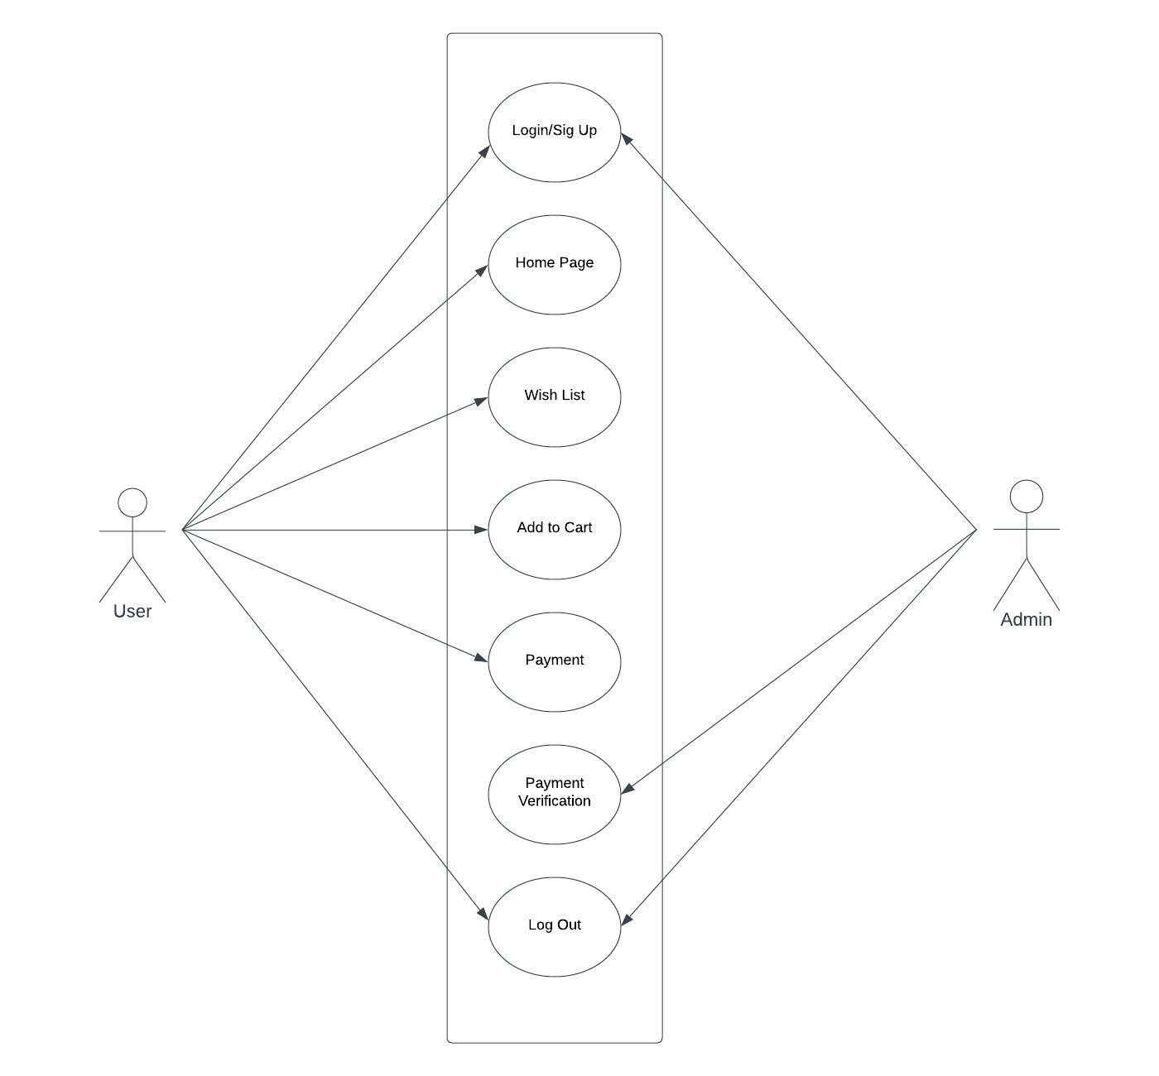

1. Text Box**Class diagram**

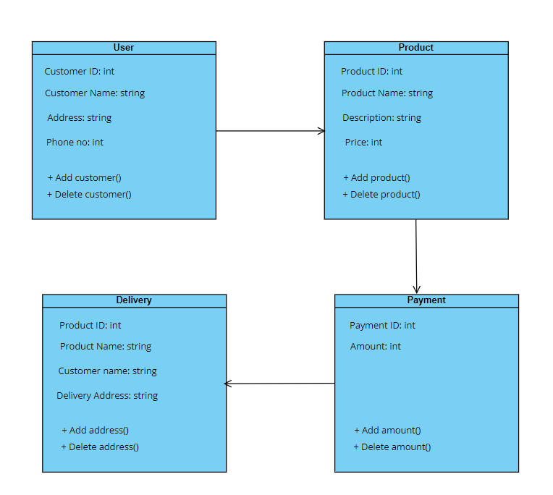

1. **Flow chart**

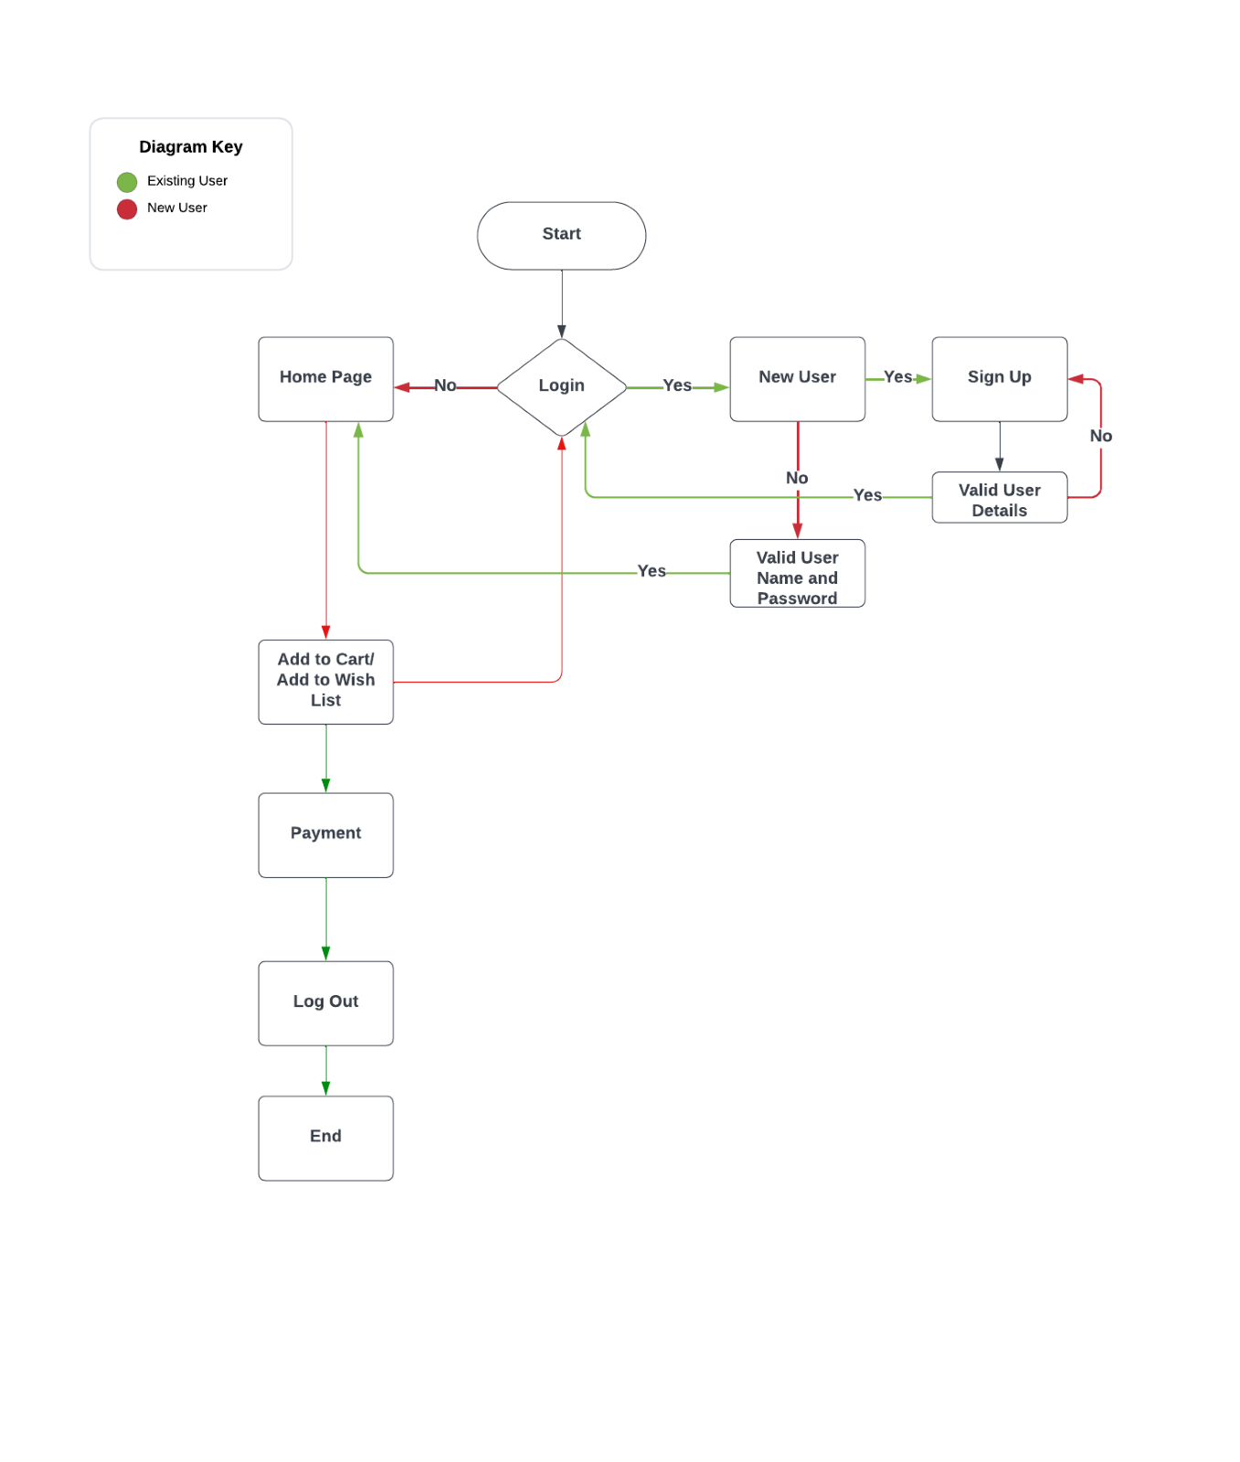

1. **Entity relationship diagram**

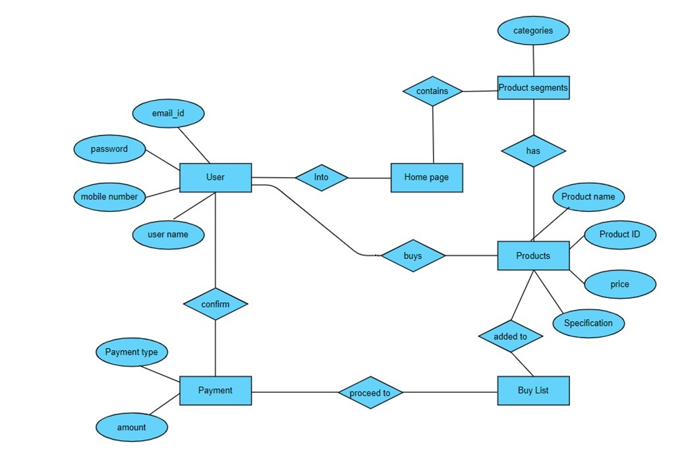

1. **Sequence diagram**

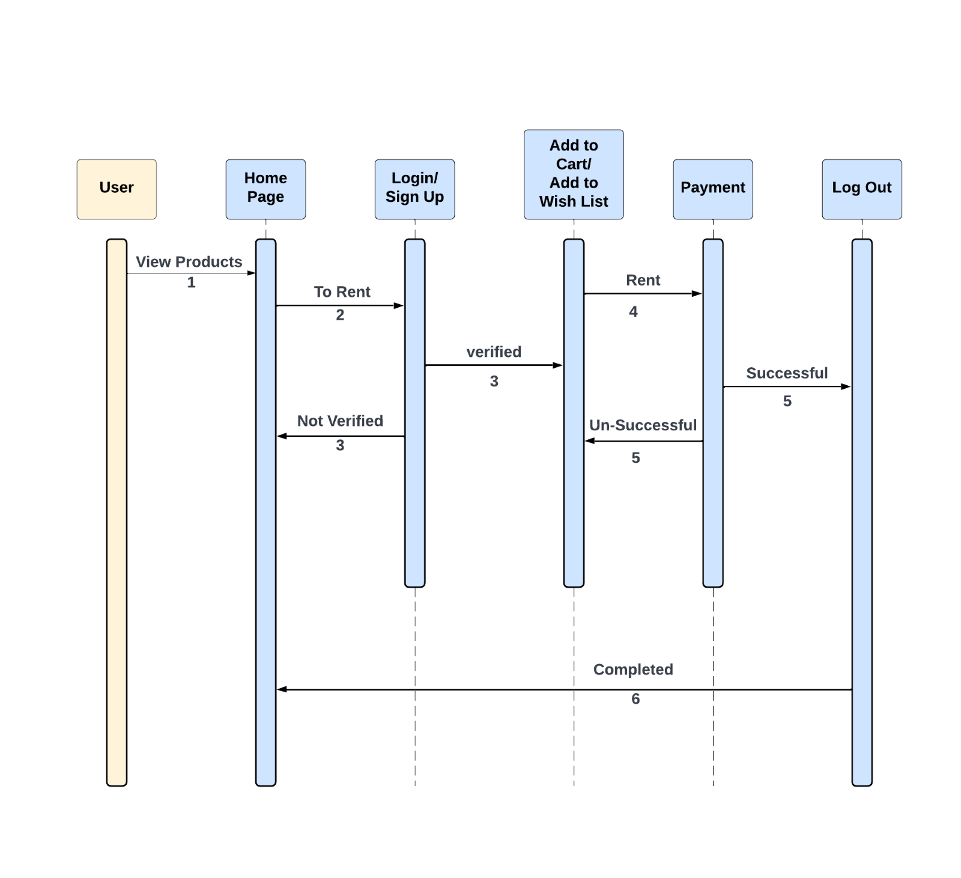

**7. Test case**

* User cannot able to enter with wrong password.
* When user click on add to wish list radio button then the product is saved in the wish list page.
* When user click on add to list then it is added to the list page.
* Amount is calculated according to the number of hours given on every product.
* Content in the page is aligned to right position when the screen size is reduced.